Assignment 2

Part II
1. Successfully deploy the infrastructure
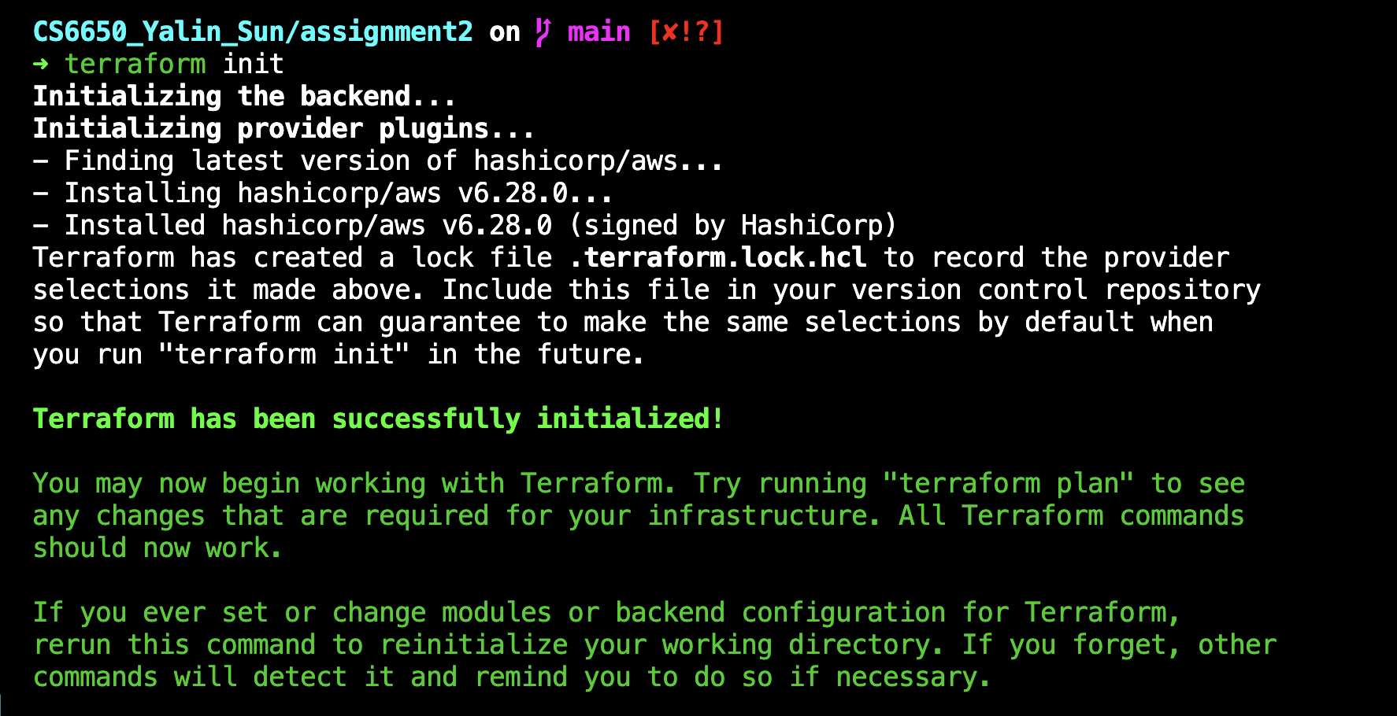

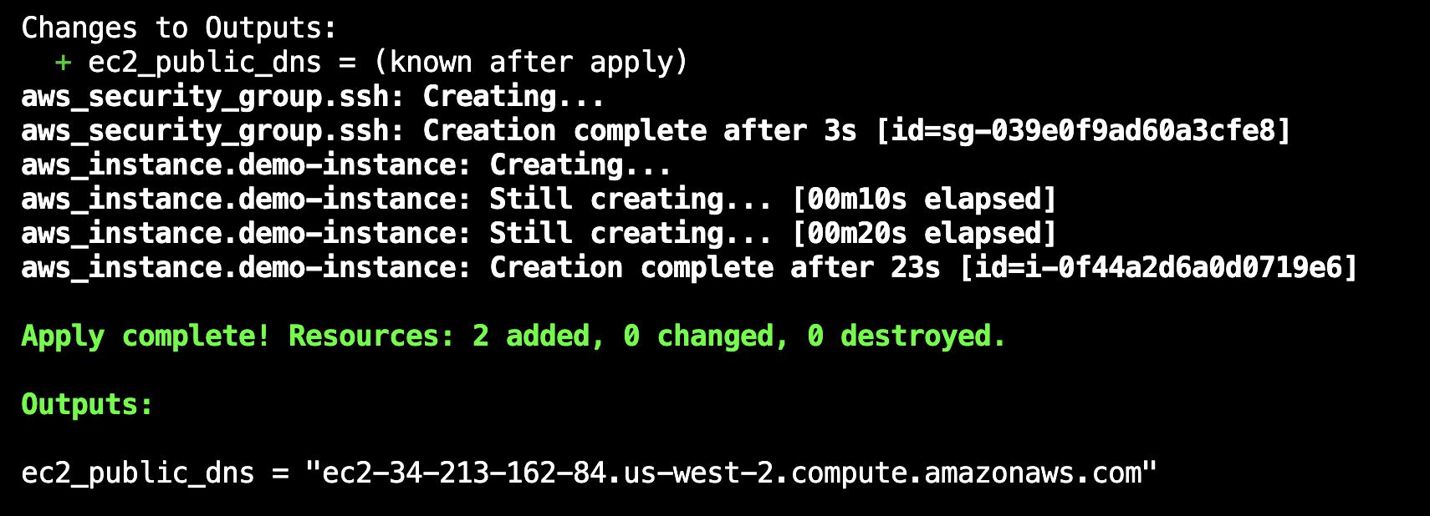

2. Connected via SSH
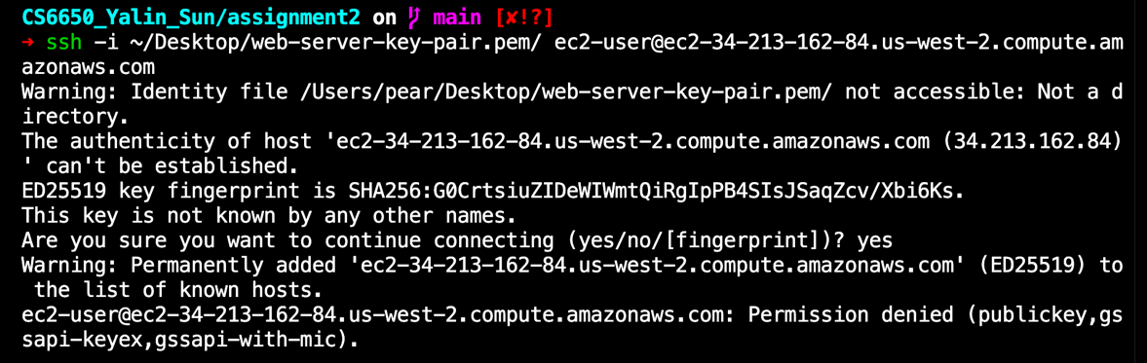

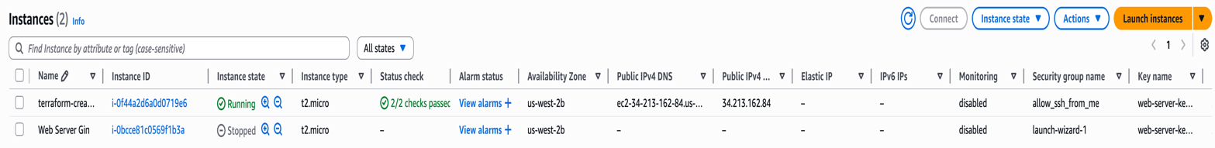
3. Clean up the instance
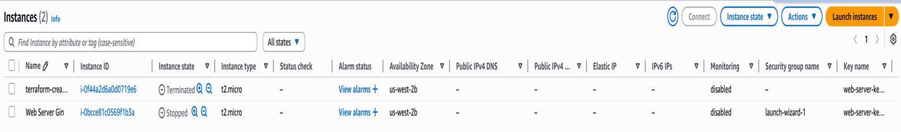

Part III

1. Build Images
(1) Created Docker images from the Dockerfile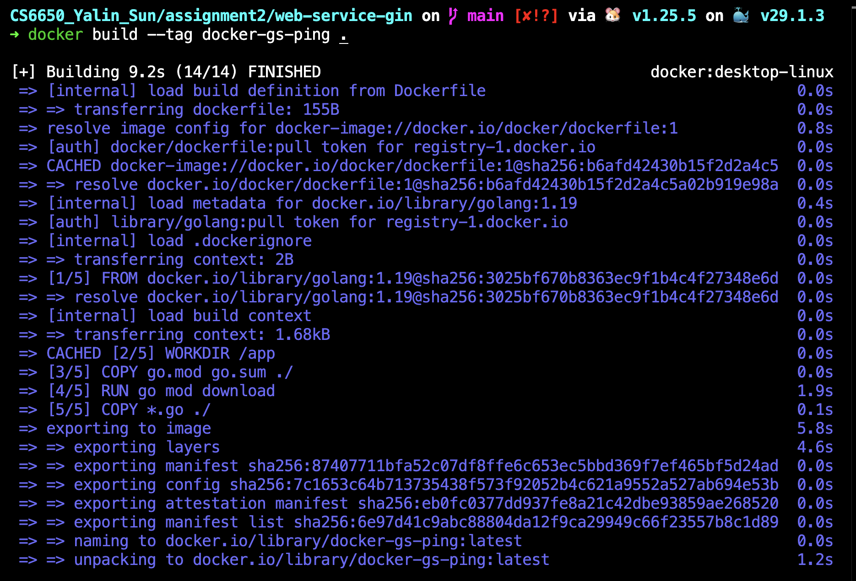

(2) View local images
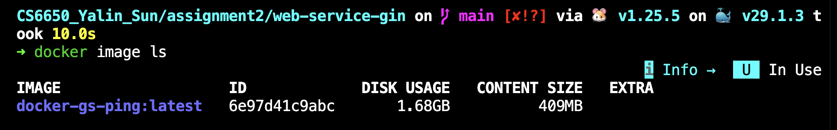

(3) Tag images
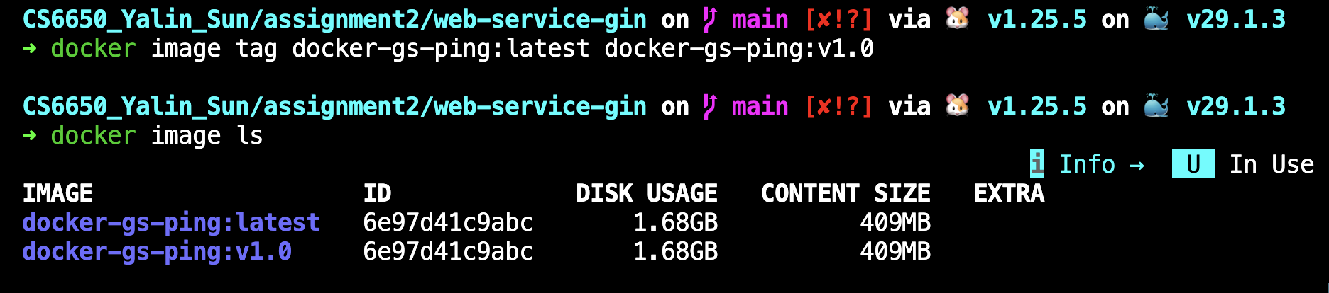

(4) Remove the tag
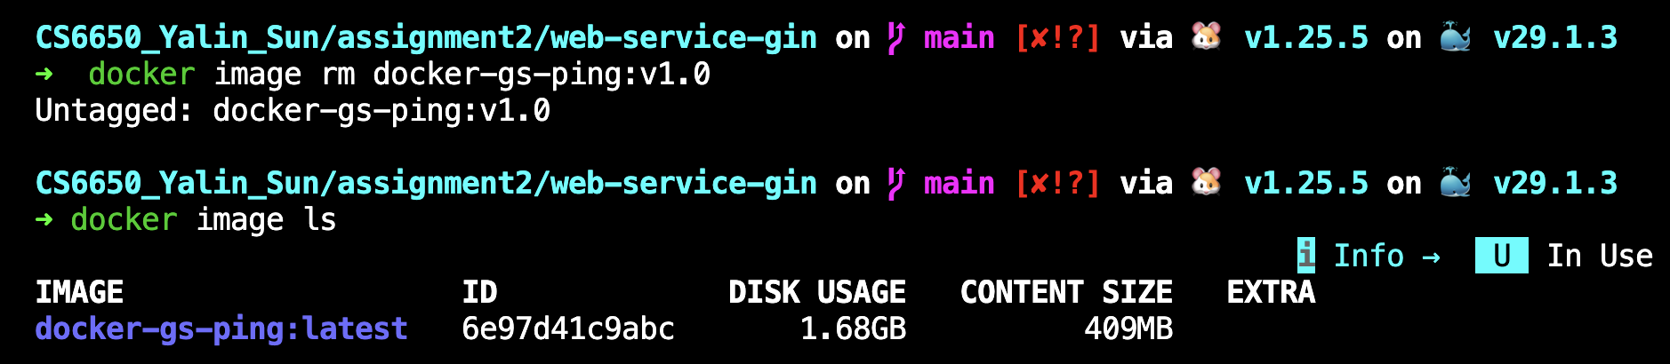

(5) Multi-stage builds
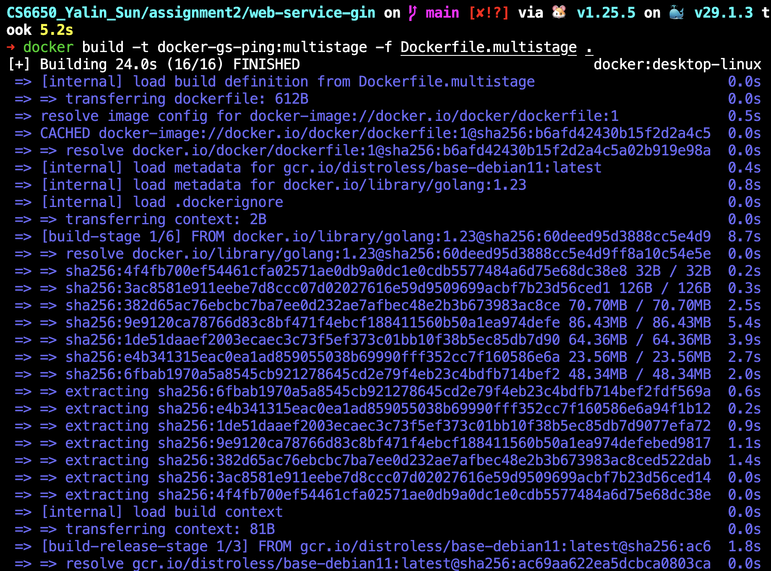

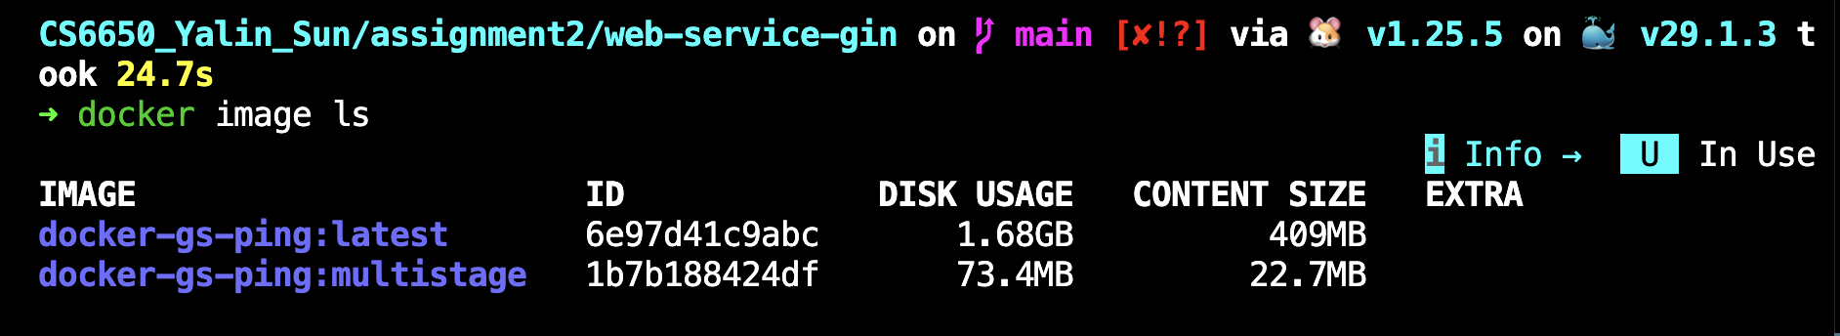

2. Run Containers
(1) run containers
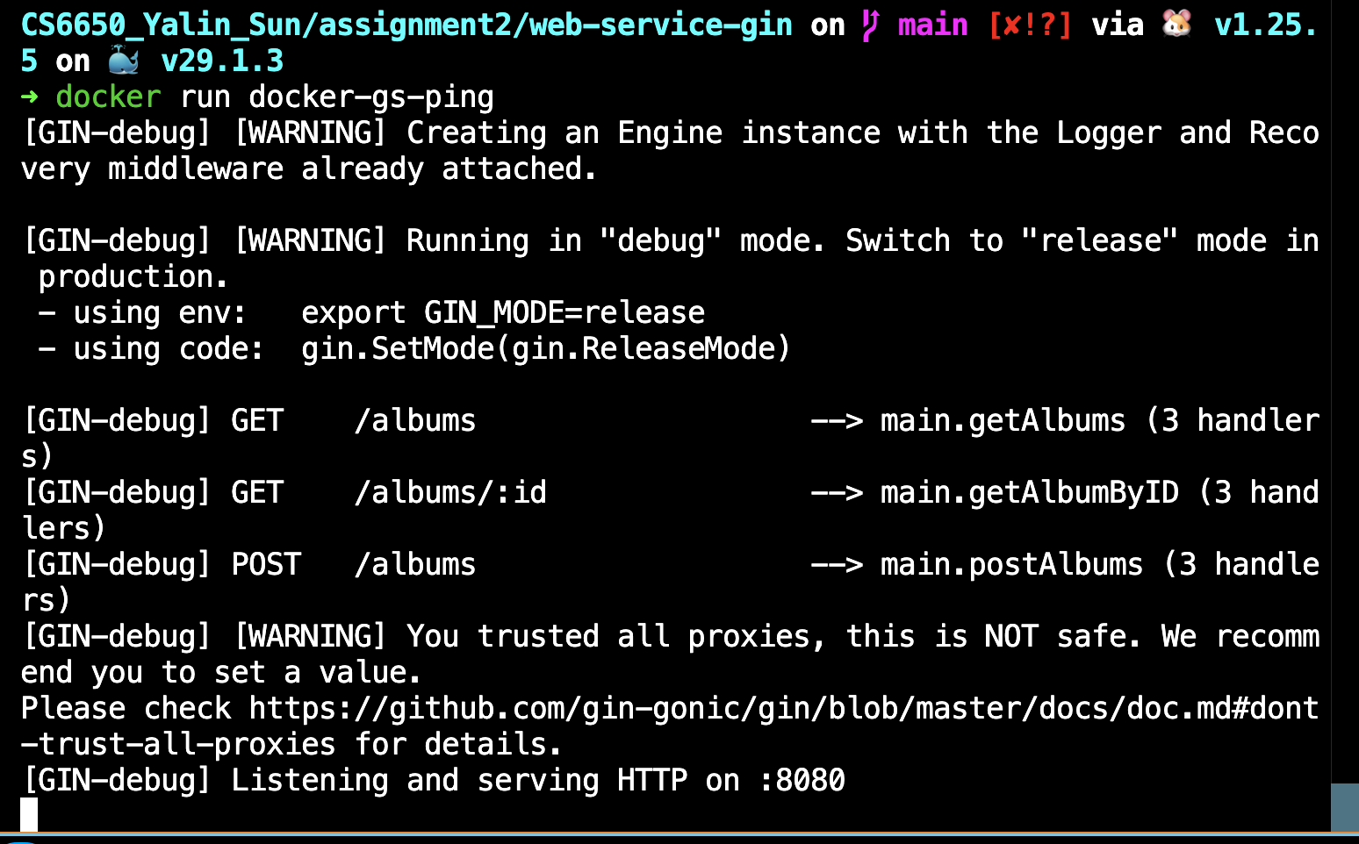

(2) Send request
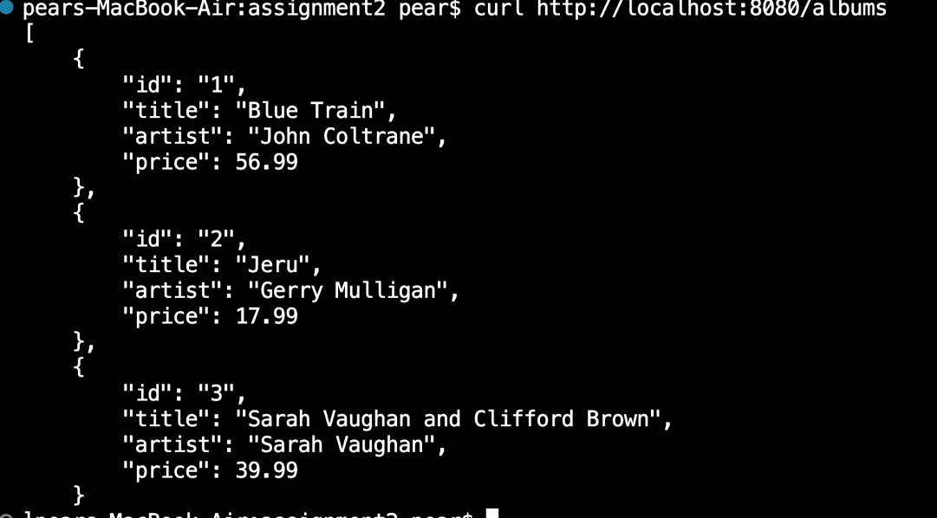
(3) Post request
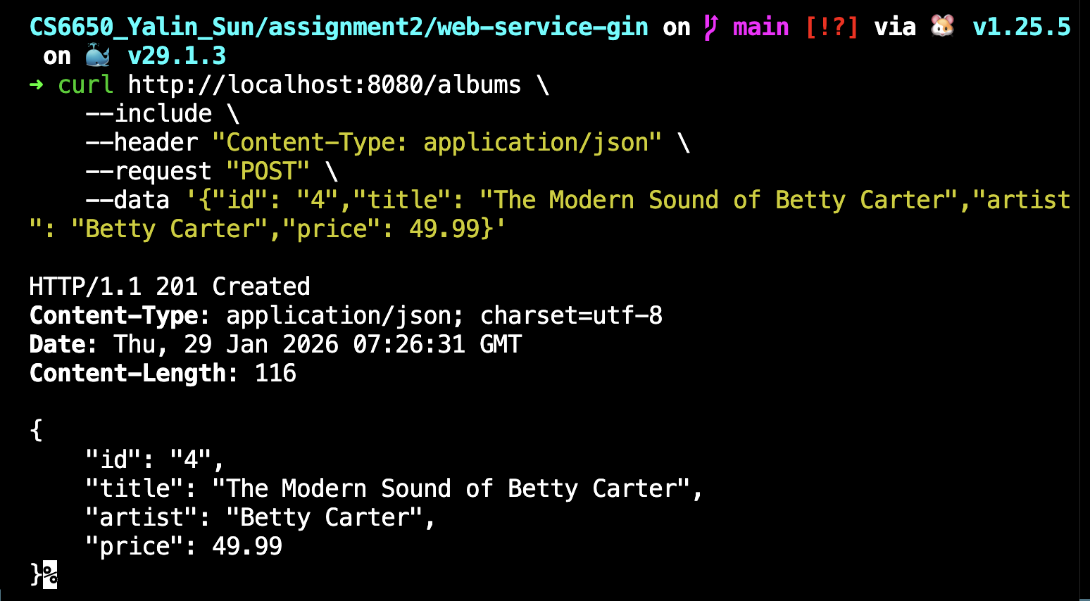

3. Run on cloud
(1) Install git
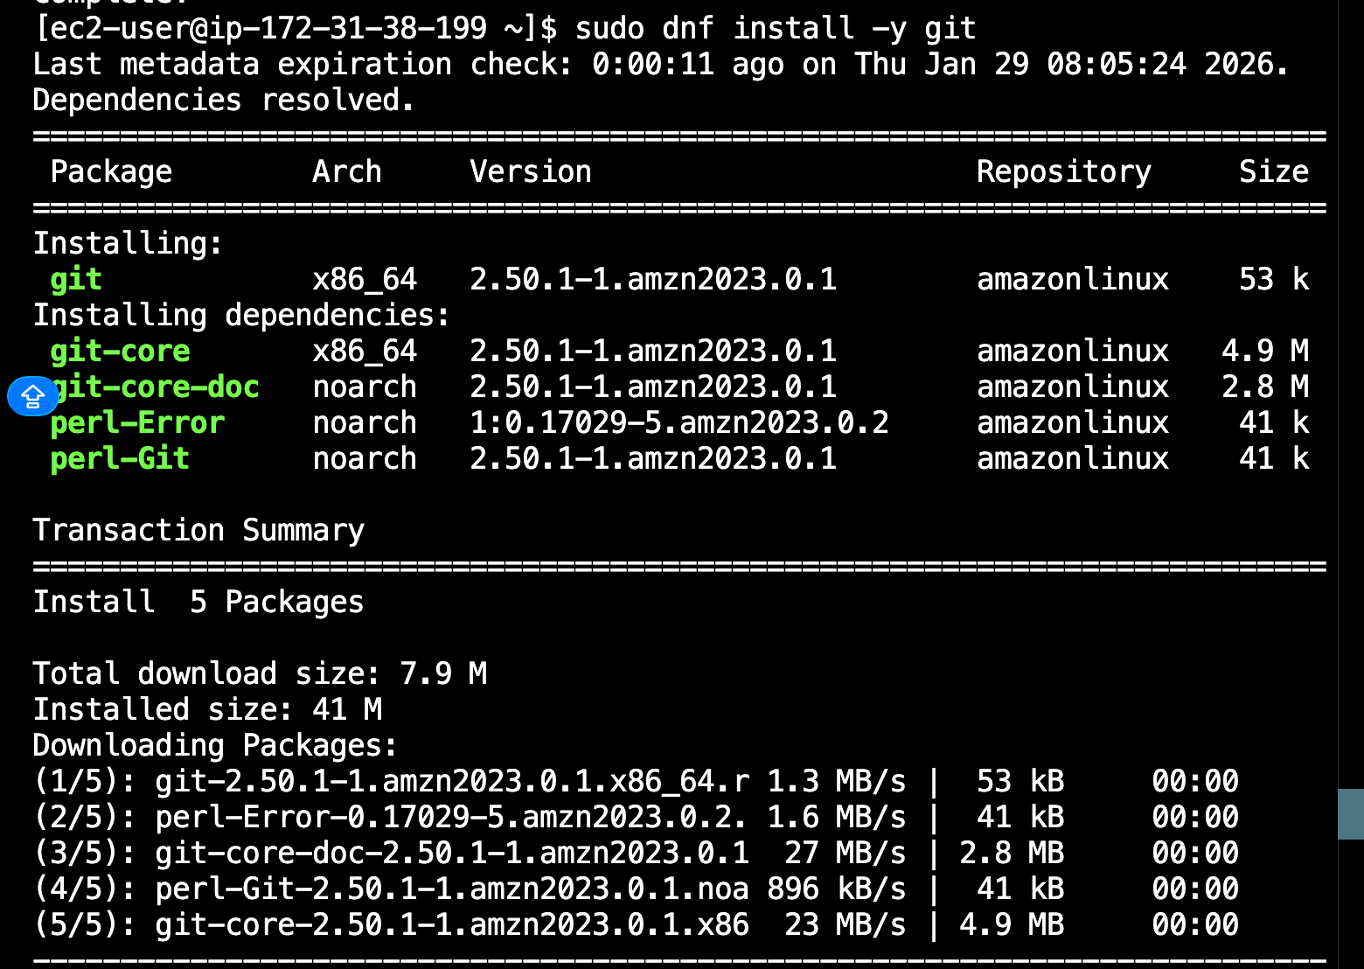
(2) Install docker
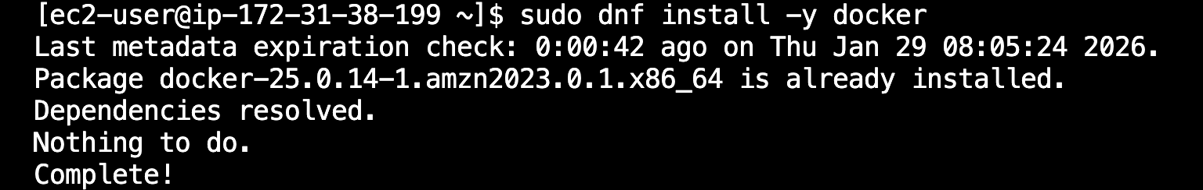

(3) Start docker
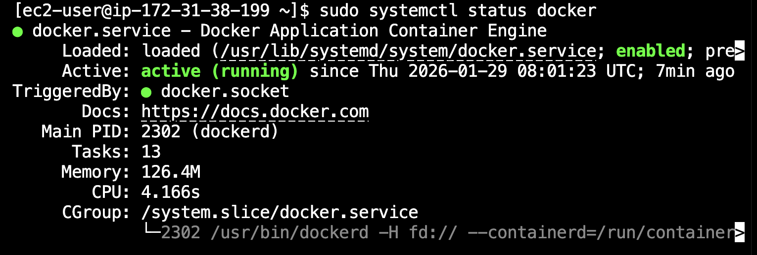

(5) Clone GitHub Repo
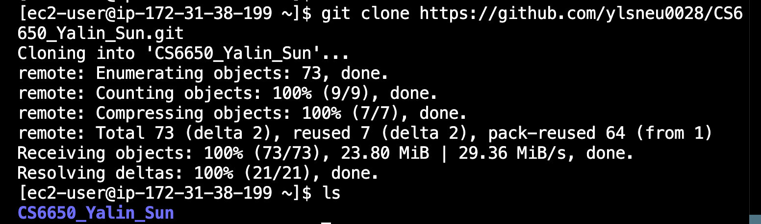

(6) load docker on EC2 and run it
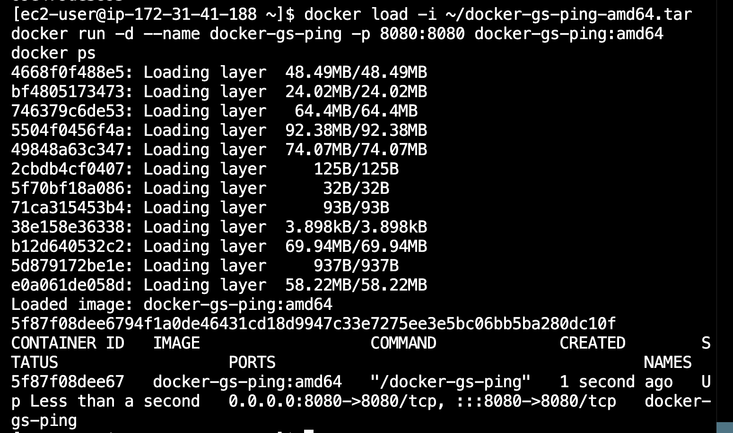

(7) GET request
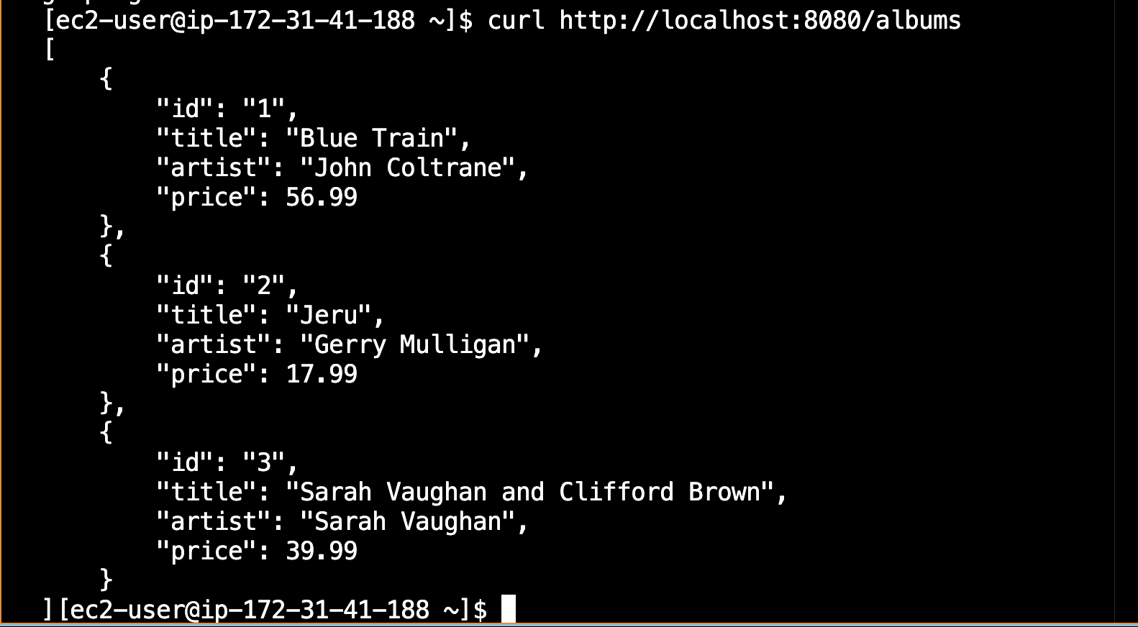

(8) POST request
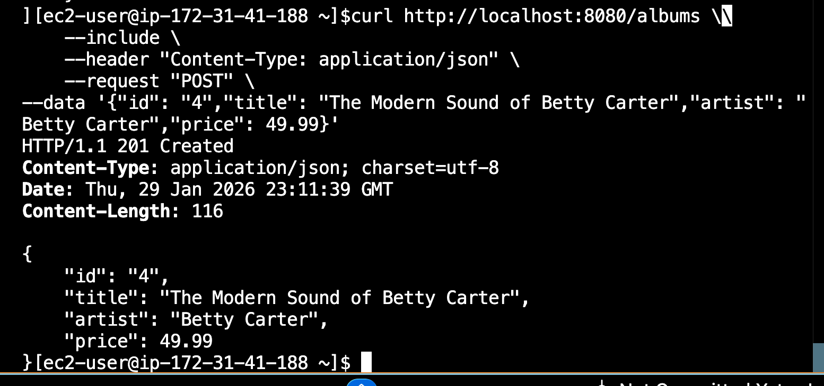

Part IV

1. Create two instances using Terraform
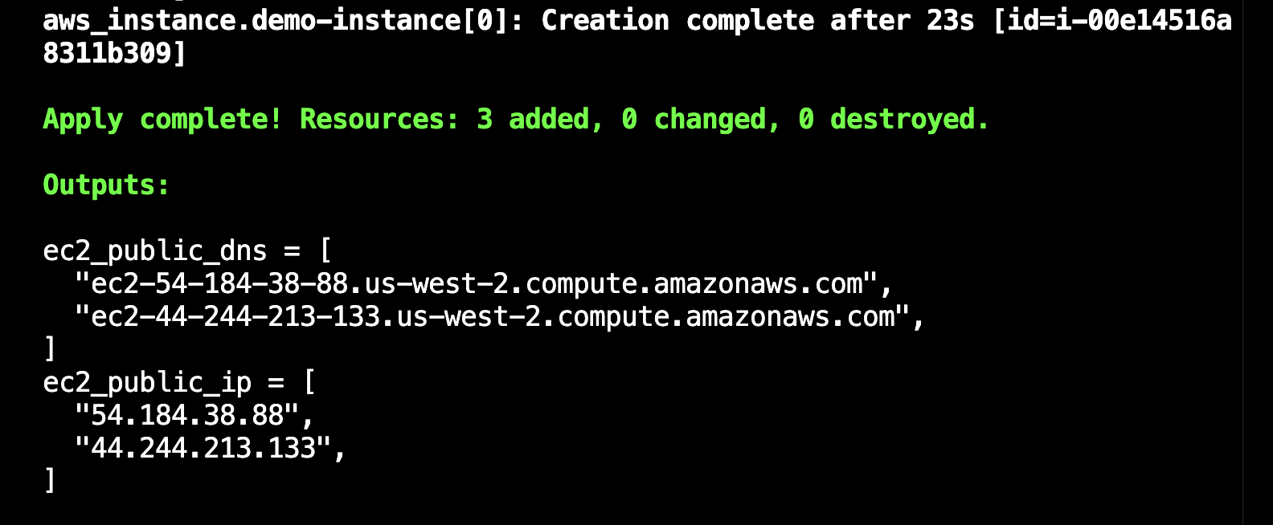

2. Load and run the docker on first instance
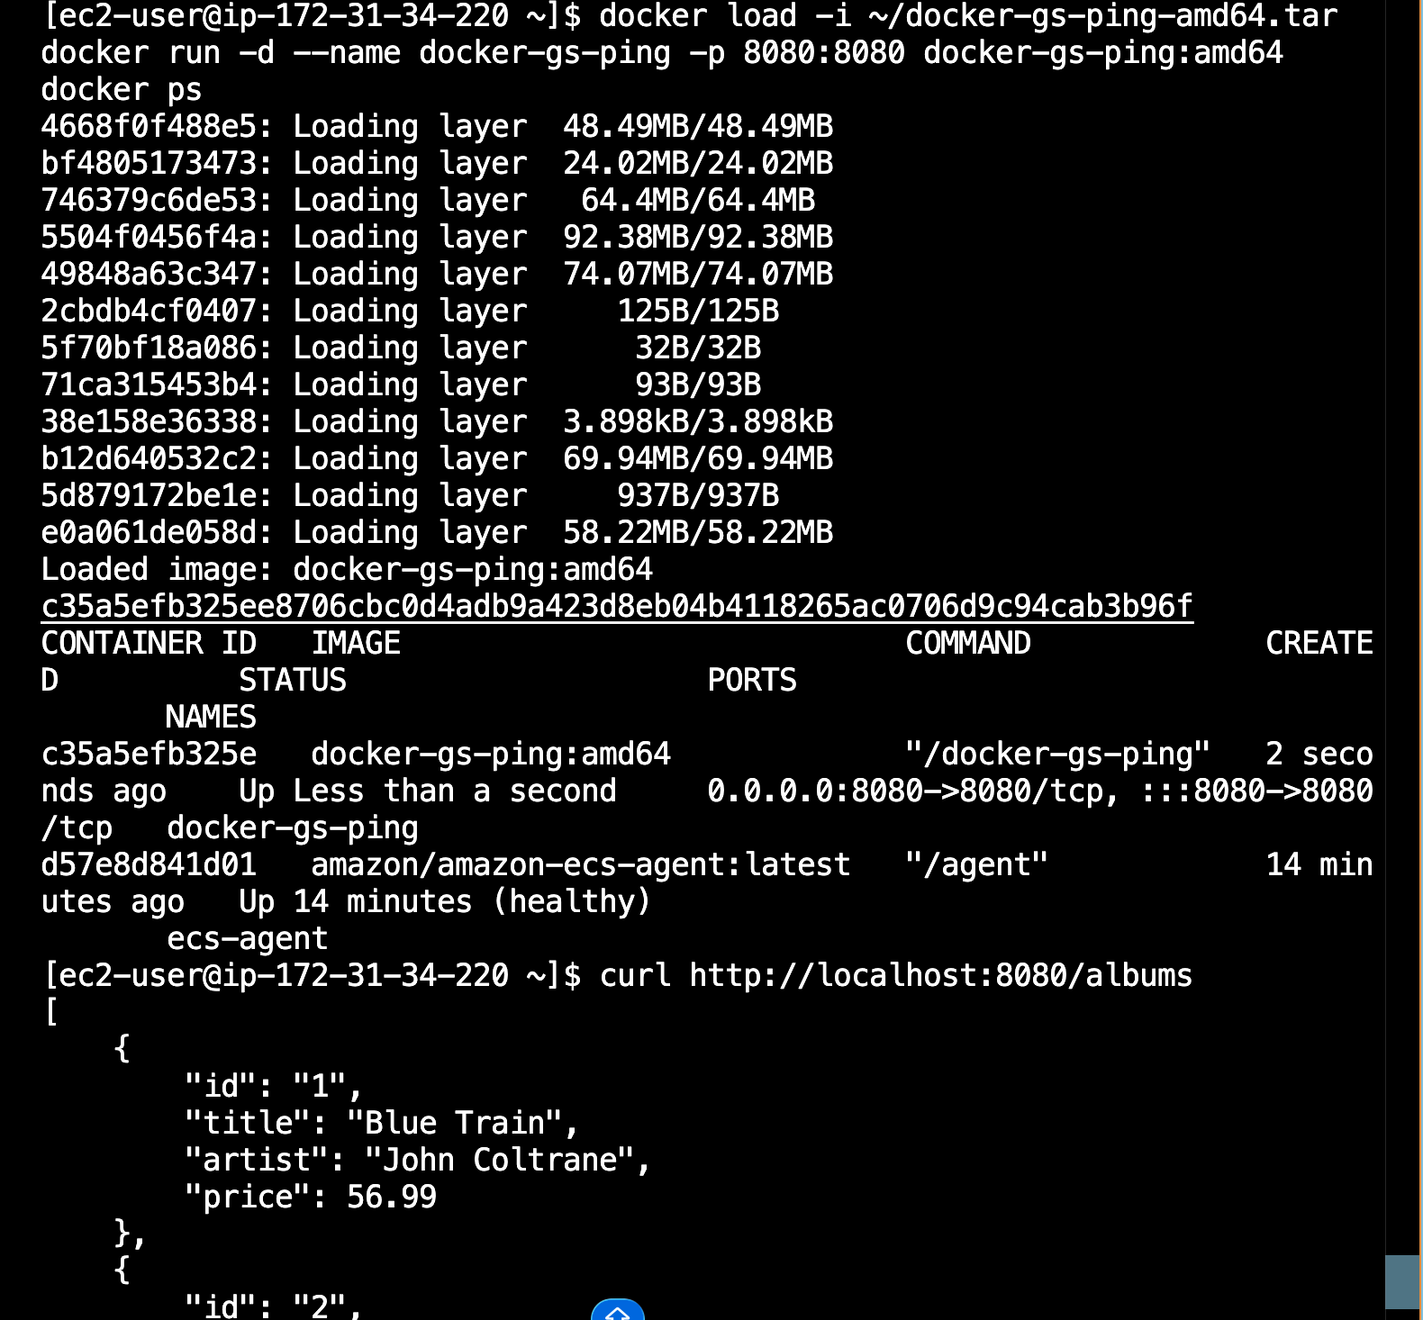

3. Load and run the docker on second instance
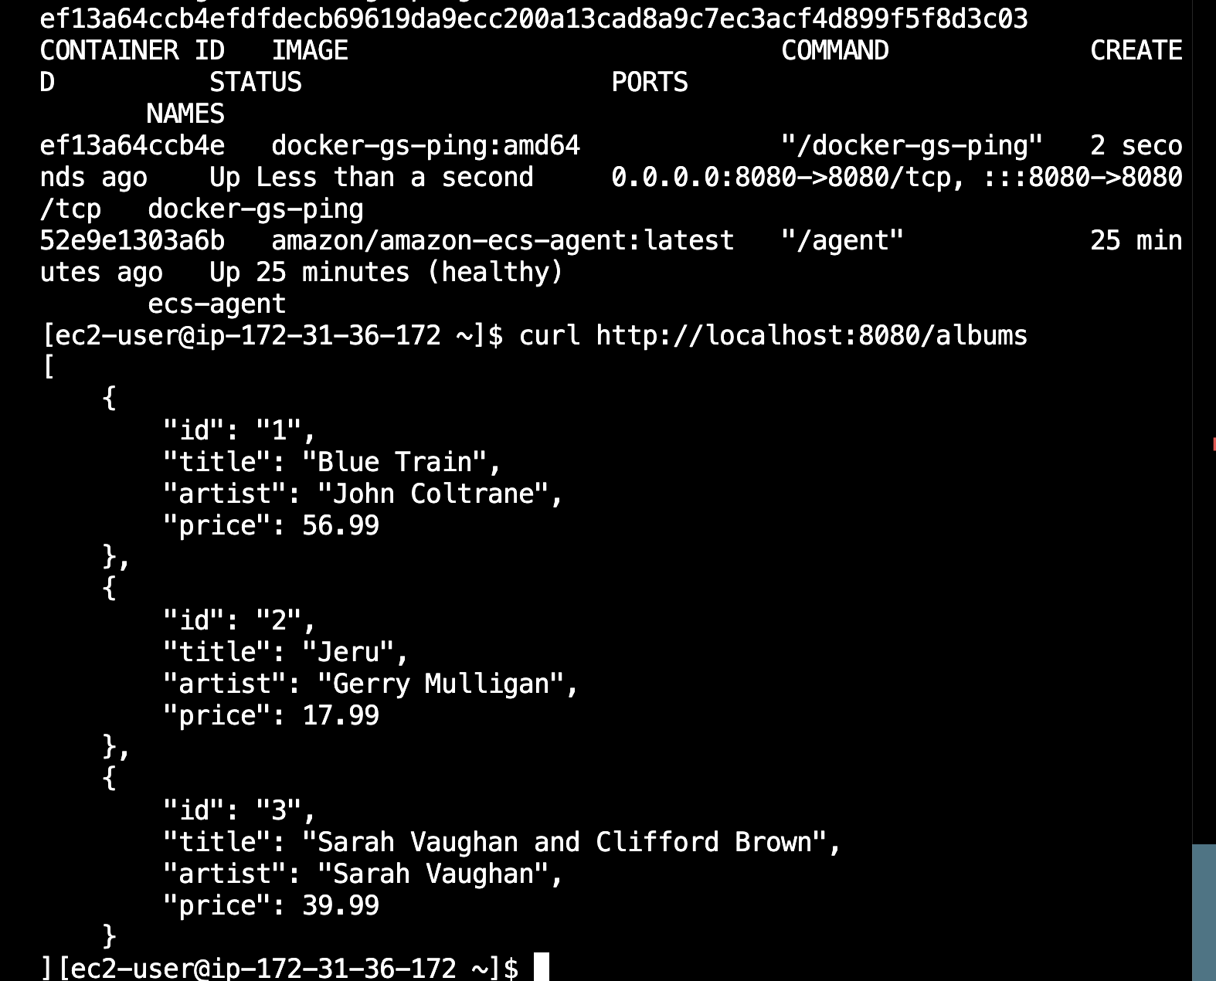

4. Run test_two_ec2.py and get the result
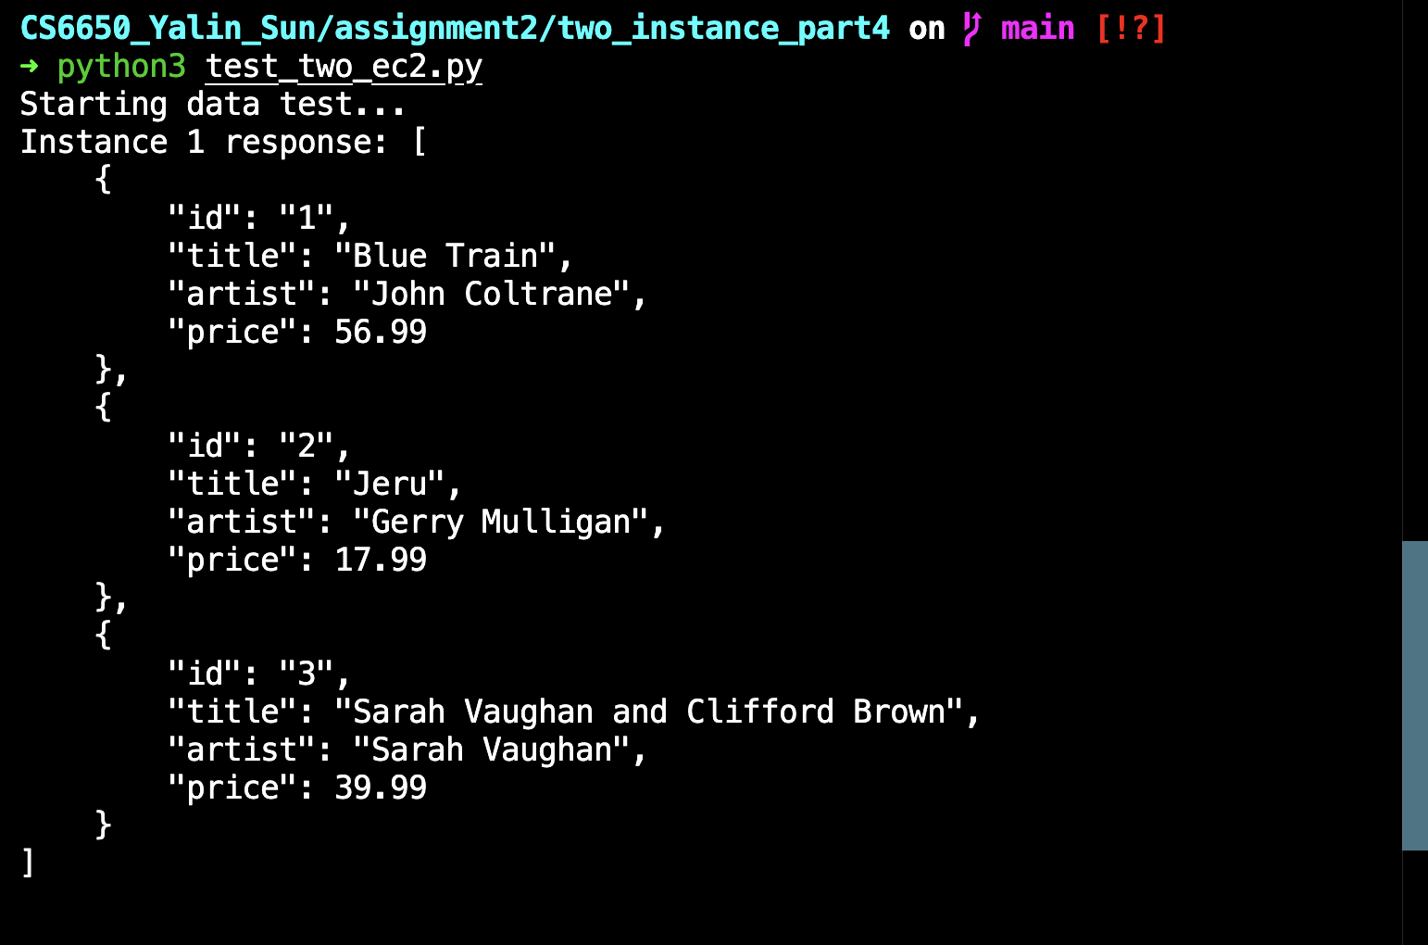
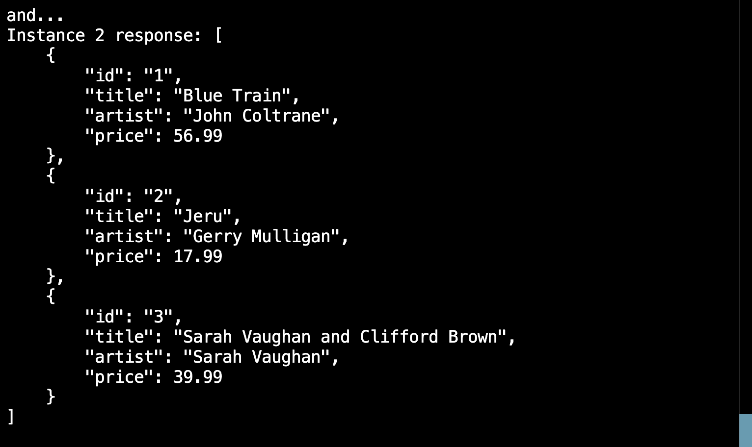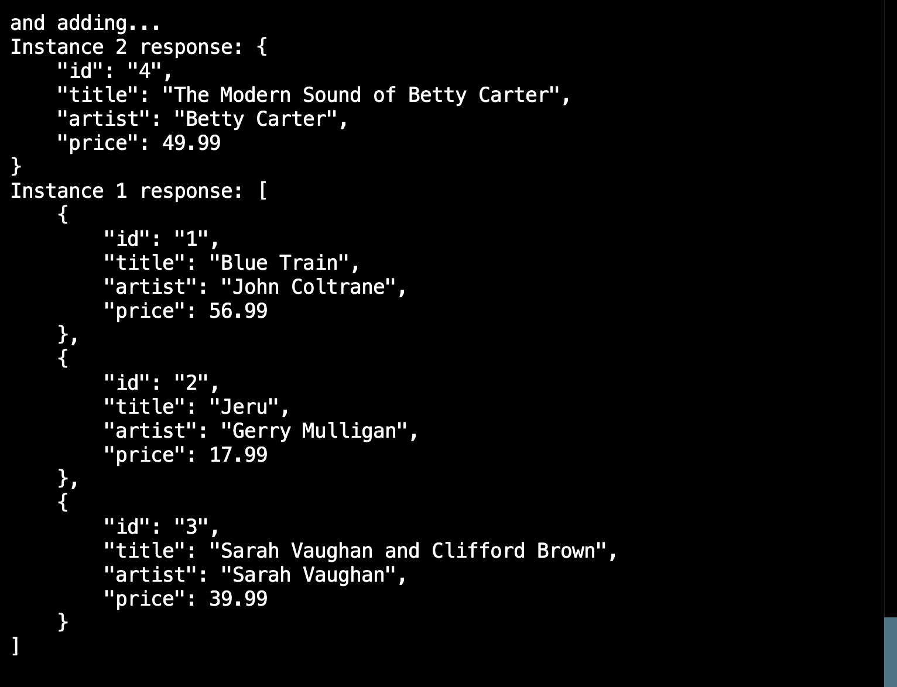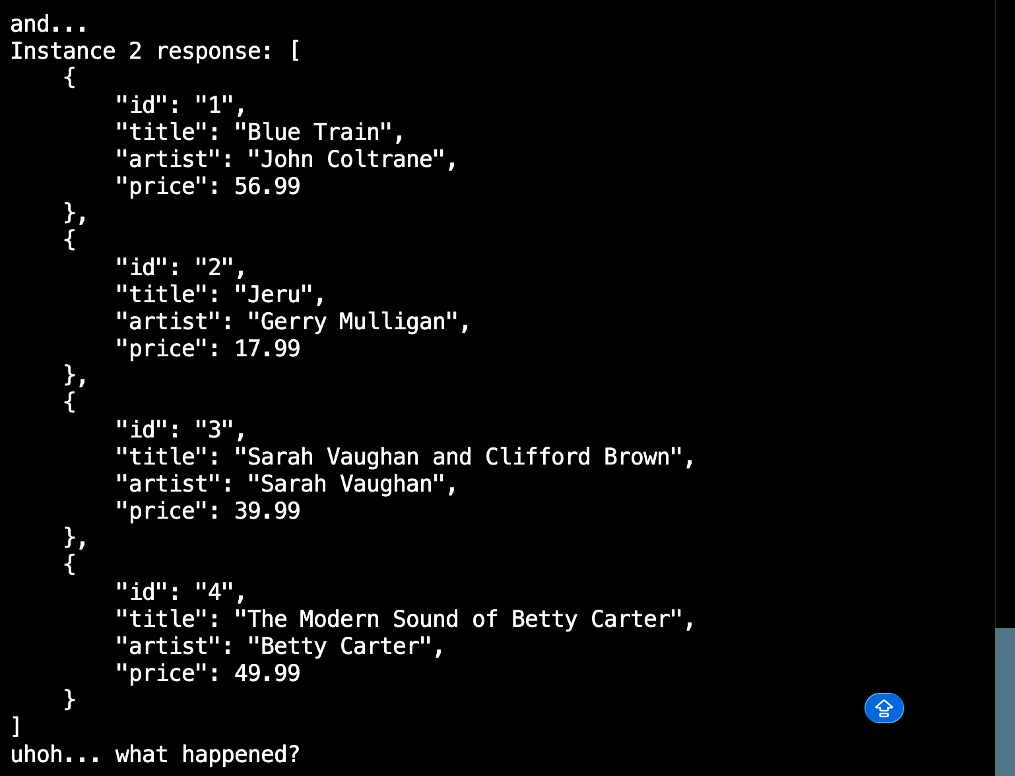

Comments on What Happened:

When we send requests to the two EC2 instances for the first time, both of them return the same result, which contains three album records. However, after we send a POST request to Instance 2 to add a new album, the second round of GET requests returns different results. Instance 2 now contains four album records, including the newly added one, while Instance 1 still only returns the original three records.

This happens because the two EC2 instances are independent from each other. Each instance runs its own container and maintains its own in-memory data and process space. The POST request only updates the data stored in Instance 2, and there is no mechanism for synchronizing data between the two instances. Since the application does not use a shared database or any data replication mechanism, the state change in one instance is not reflected in the other. As a result, the two instances return inconsistent results.

Part V

